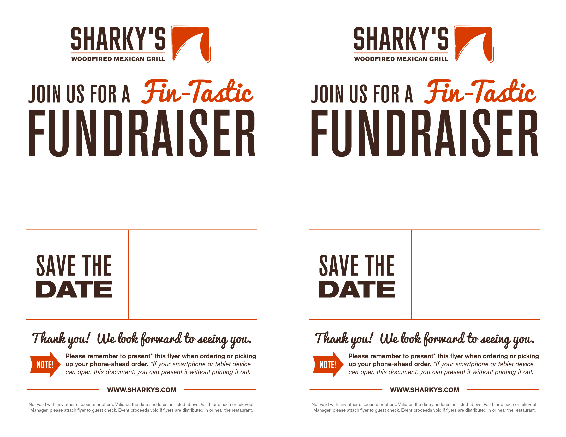

**THE AMERICAN YOUTH FOUNDATION**

**THE AMERICAN YOUTH FOUNDATION**

**THursday august 22nd, 2019**

**11am – 9pm**

Woodland Hills (818-887-6963)

The Office Depot Shopping Center

Corner of Erwin and Topanga Cyn

Dine In. Call Ahead. Take-Out.

**THURSDAY AUGUST 22ND, ,2019**

**11am – 9pm**

Woodland Hills (818-887-6963)

The Office Depot Shopping Center

Corner of Erwin and Topanga Cyn

Dine In. Call Ahead. Take-Out.

Enjoy Fin-tastic food & help raise money $$ for our organizaionl. Bring this flyer and **20% Net Sales** will benefit:

Enjoy Fin-tastic food & help raise money $$ for our organizaiton. Bring this flyer and **20% Net Sales** will benefit: